# JS Advanced: Retake Exam - 10.12.19

Exam problems for the ["JavaScript Advanced" course @ SoftUni](https://softuni.bg/courses/js-advanced). Submit your solutions in the SoftUni Judge system at <https://judge.softuni.bg/Contests/Compete/Index/1850#0> .

# Problem 1. Christmas Gifts Delivery (DOM Manipulation)

### Use the given skeleton to solve this problem.

### Note: You have NO permission to change directly the given HTML *(index.html file)*.

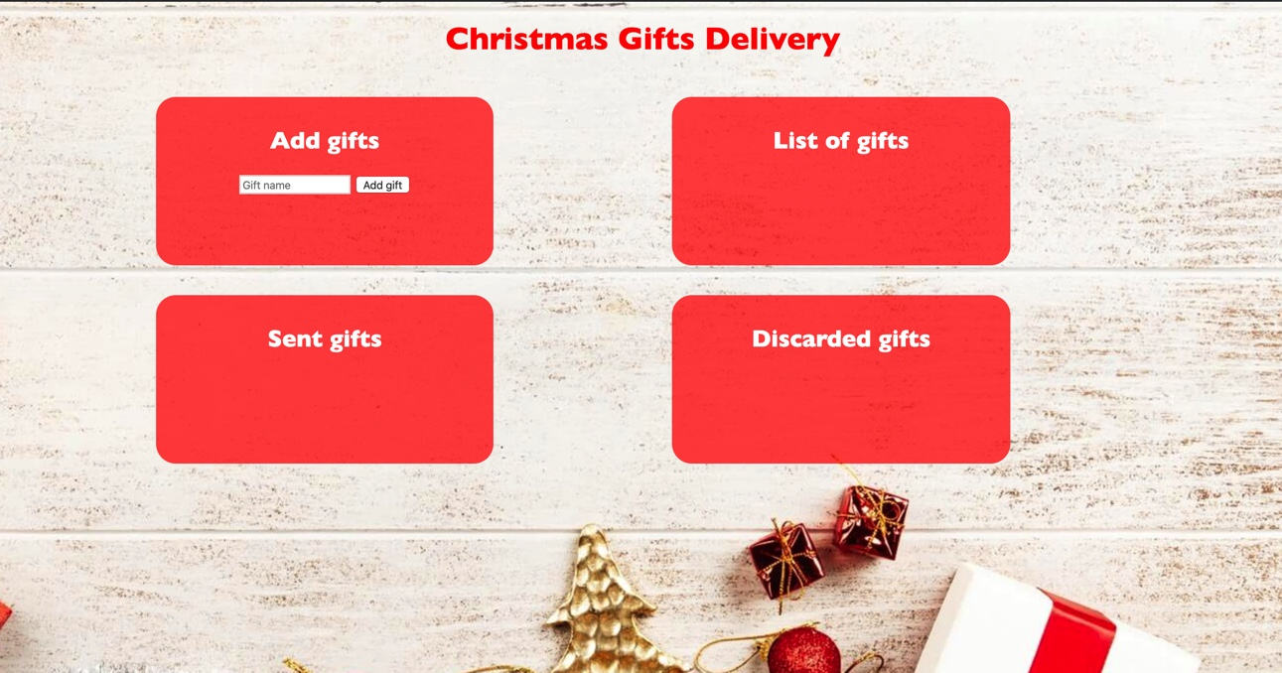

### Your Task

Write the missing JavaScript code to make the Christmas Gifs Delivery application work as expected.

You should be able to **add** new gifts to the list of gifts.

Each product has **name**. When you click the **[Add gift]** button, a new **list item** should be added to the **List of gifts**. To each list item you should put a **class “gift”**. Upon clicking the **[Add gift]** button you should **sort** the gifts **in alphabetical order** and you should **clear the input field.**

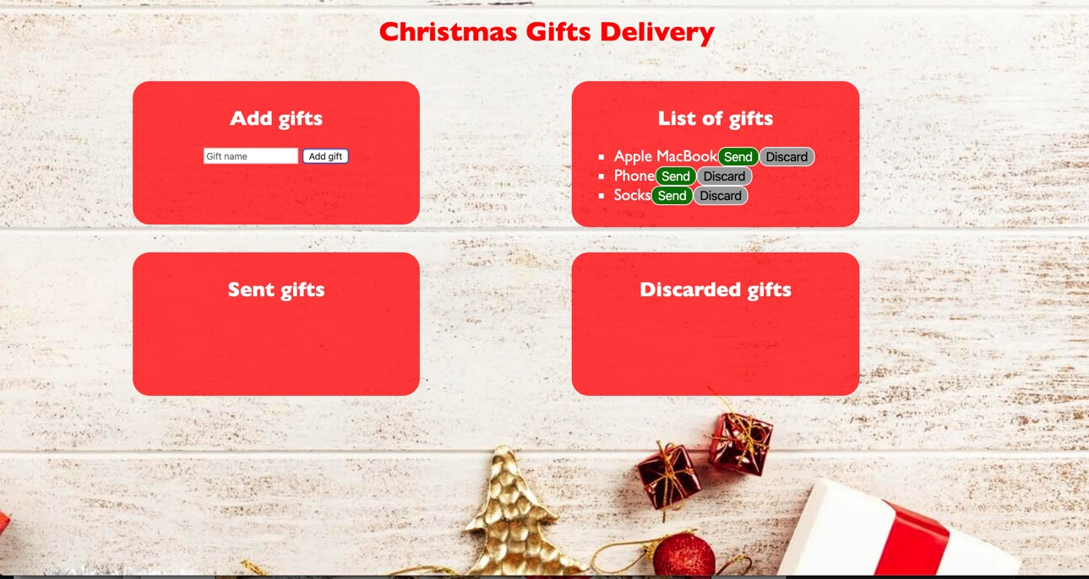

The new item should have the **following structure**:

* Append two buttons to each list item
  + Add class **“gift”** to each list item
  + **[Send]** button with **class** **“sendButton”**
  + **[Discard]** button with **class** **“discardButton”**

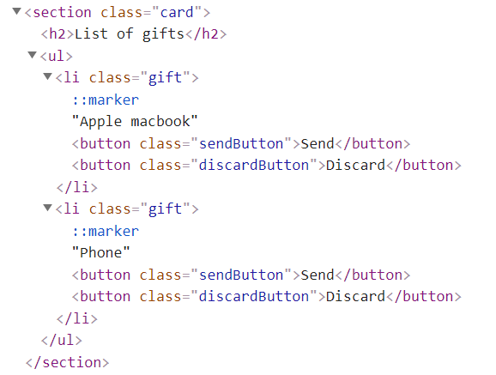

When you click the **[Send]** button you should move the list item to the **Sent gifts** section. **Important!** Do not move the entire list item, but only the name of the gift. You should leave the buttons behind.

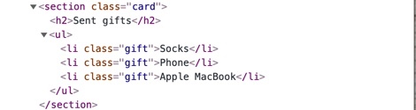

When you click the **[Discard]** button you should move the list item to the **Discarded** gifts section. **Important!** Do not move the entire list item, but only the name of the gift. You should leave the buttons behind.

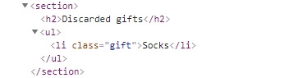

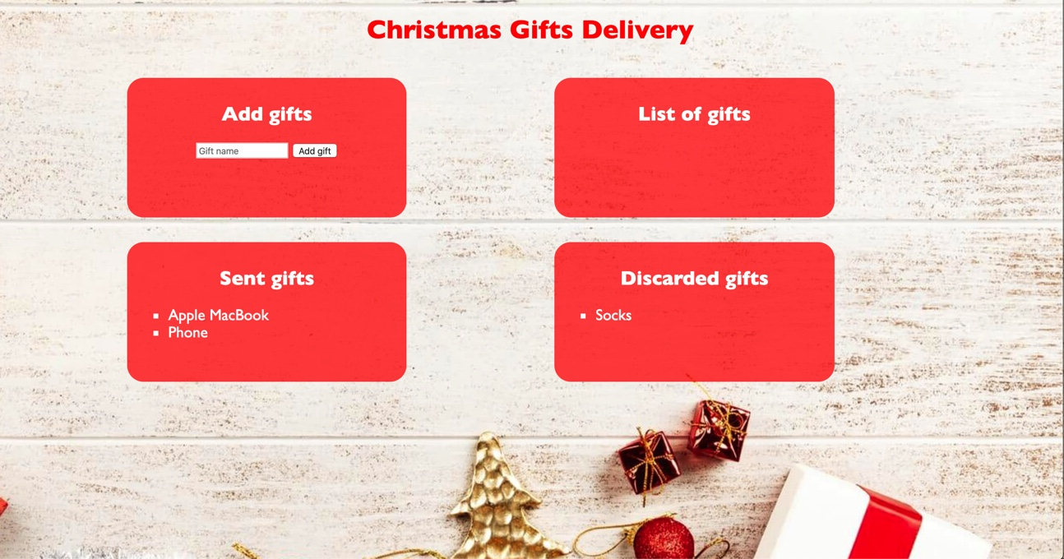

function solution() {

    const input = document.querySelector('input');

    const button = document.querySelector('button');

    const [

        listOfGifts,

        sendGifts,

        discardedGifts] = Array.from(document.querySelectorAll('section ul'));

    button.addEventListener('click', addGift);

    function addGift() {

        const giftName = input.value;

        input.value = '';

        const li = giftsConstructor('li', giftName, 'gift');

        const sendBtn = giftsConstructor('button', 'Send', 'sendButton');

        sendBtn.addEventListener('click', () => sendGift(giftName, li));

        const dscrdBtn = giftsConstructor('button', 'Discard', 'discardButton');

        dscrdBtn.addEventListener('click', () => discardGift(giftName, li));

        li.appendChild(sendBtn);

        li.appendChild(dscrdBtn);

        listOfGifts.appendChild(li);

        sortGifts();

    };

    function sendGift(giftName, element) {

        element.remove();

        const newElement = giftsConstructor('li', giftName, 'gift');

        sendGifts.appendChild(newElement);

    }

    function discardGift(giftName, element) {

        element.remove();

        const newElement = giftsConstructor('li', giftName, 'gift');

        discardedGifts.appendChild(newElement);

    }

    function sortGifts() {

        Array.from(listOfGifts.children)

            .sort((a, b) => a.childNodes[0].textContent.localeCompare(b.childNodes[0].textContent))

            .forEach(g => listOfGifts.appendChild(g));

    }

    function giftsConstructor(type, txtContent, className) {

        const el = document.createElement(type);

        el.textContent = txtContent;

        if (className) {

            el.className = className;

        }

        return el;

    }

}